Admin User Manual
FOR

LICENSE WEB APPLICATION
SUBMITTED TO
IVTECH COMPUTER SYSTEMS LLC

Version: 1.1

09th OCTOBER- 2025

Prepared By:
SPEC INDIA
Revision History

Date | Version | Author | Created / Updated / Reviewed / Verified / Approved By
09-10-2025 | 1.1 | Krunal Thakkar | - Initial draft
10-10-2025 | 1.1 | Jigar Modi | - Reviewed and approved

Table of Contents
Contents
1. Introduction 4
1. Getting Started 4
1.1. Login Process: 4
1.2. Forgot Password: 5
2. Navigation Overview 7
3. User Management 9
3.1 Users: 9
3.2 Roles: 13
3.3 Permissions 17
3.4 Role Assignment: 19
4. Distributors Management 21
5. Customers & Licenses Management 26
5.1 Customers: 26
5.2 Licenses: 30
6. Profile & Password Management 33
6.1 Profile: 33
6.2 Change Password: 34
7. Troubleshooting Tips 37
8. Support Contact 38

- Introduction

- Purpose: This manual is a step-by-step operational guide for administrators and Sub-users of the License Web Application developed by SPEC INDIA. It explains access, navigation, user & role management, distributor & customer management, license generation (trial & permanent), system behaviors and business rules that apply to day-to-day admin operations.

- Audience:
  - Super Admin — full access; seeds an initial account when environment deploys. This user can create other users, roles, permissions, distributors, customers and generate licenses.
  - Sub-user — created by Super Admin (or authorized user having required permission to create new users); assigned one or more roles; access governed by role permissions.

Getting Started
- This section explains how users can log in to the License Web Application and recover their password if forgotten.

Login Process:

- Screen:
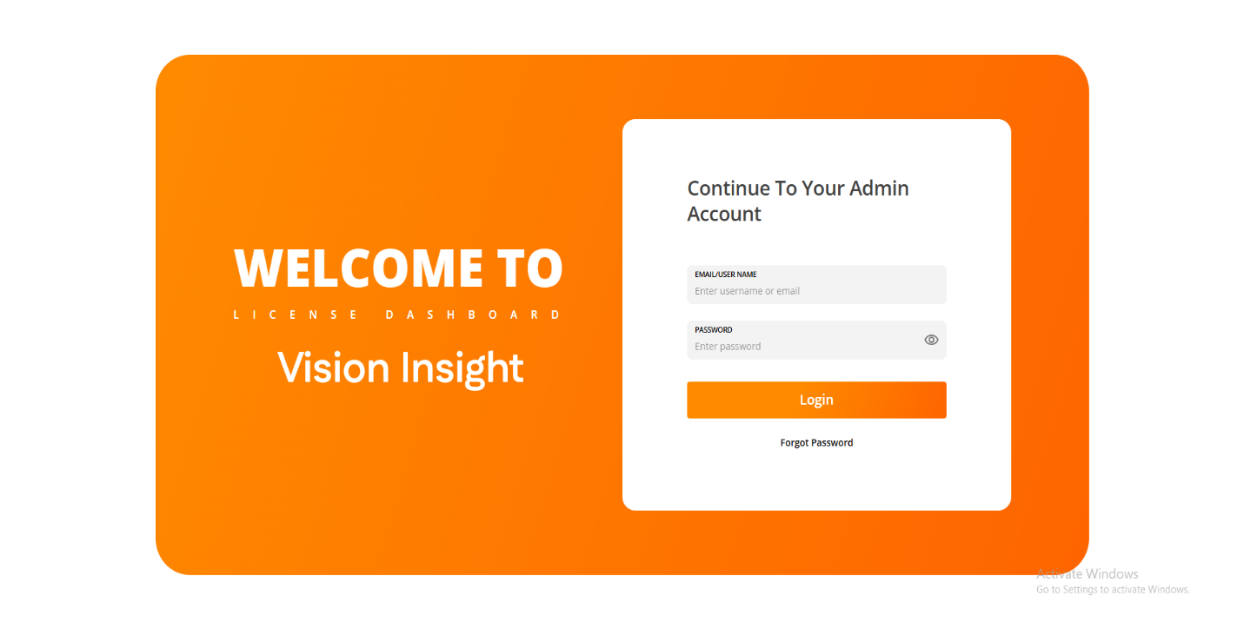
- Steps to Login:
  - Enter Username or Email and Password.
  - Click Login.
  - On successful validation user is redirected to Customers & Licenses (Landing) page.
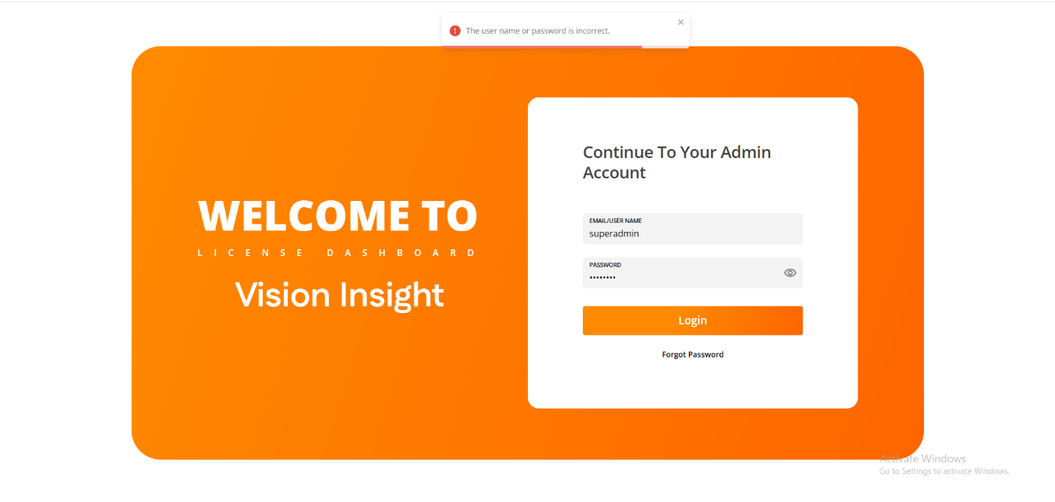
  - If invalid credentials are entered, appropriate validation message will be displayed.
  - If account is Inactive/Deleted, login will be denied, and user must contact an active admin.

Forgot Password:

- Screen:
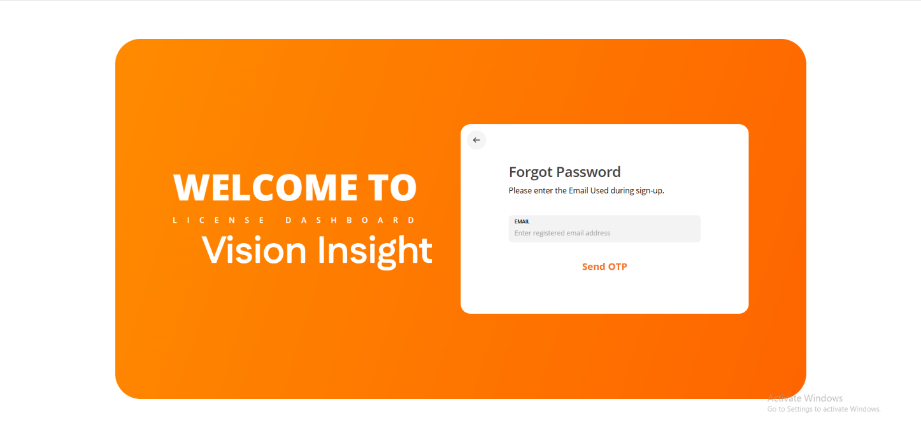

- Flow & steps:
  - Click Forgot Password → enter registered email → Click Send OTP.
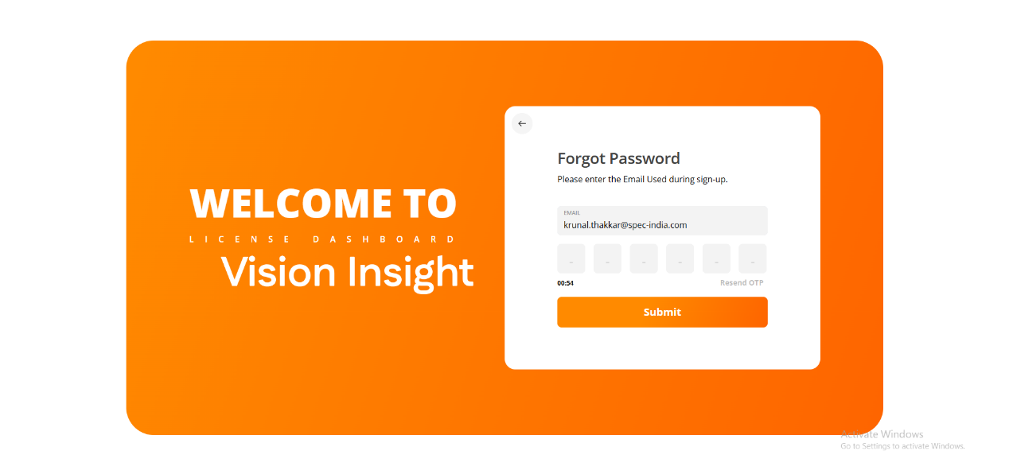
  - System will send an OTP via email (with the OTP attachment) to user’s registered email. Resend option is available after configured wait time.
  - Enter the OTP → Click Submit → system validates OTP. On success, user goes to Reset Password screen.
  - Enter New Password and Confirm Password (follow password rules) → Submit → password updated, and user will be redirected to login page if successful.

- OTP rules & notes:
  - OTP will be marked as utilized after use as once the OTP is used, it cannot be reused.
  - OTP will be valid until expiration time set.

- Password rules (applies to reset and create):
  - Minimum length: 8 characters
  - At least 1 uppercase, 1 lowercase, 1 numeric, 1 special character.

- Navigation Overview
Screen:

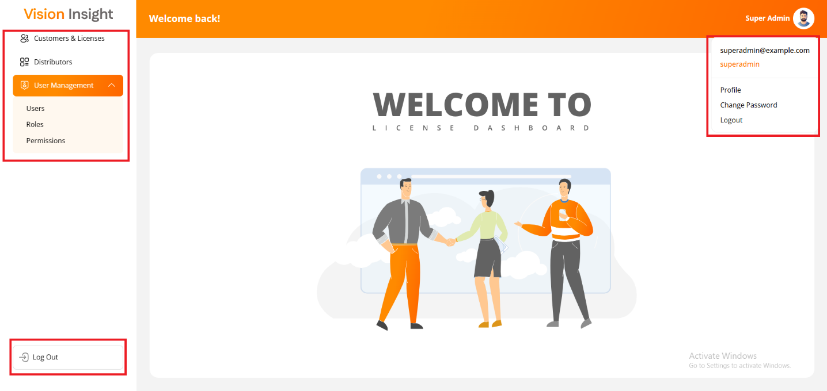

- The system allows all admin users to log in to the License Web Application and access the following menus and options:

- The following options/menus are displayed on the sidebar:
  - Customers & Licenses
  - Distributors
  - User Management
    - Users
    - Roles
    - Permissions
    - Logout

- The following options/menus display when the user clicks on their profile image in the top right-hand corner:
  - Profile
  - Change Password
  - Logout

- Access Control and Navigation Rules
  - The system interface and available menu options are customized based on the permissions assigned to each user. Please refer to the following points for clarity:

  - Role-Based access:
    - The system displays only the menus and functionalities that are allowed for the logged-in user as per their assigned permissions.

  - Common Features for All Users:
    - Regardless of assigned permissions, all users will have access to the following options:
      - Profile: View and update personal details.
      - Change Password: Update account password.
      - Logout: Securely sign out of the system.

  - Restricted Access:
    - Any menus or options that are not permitted for the logged-in user will automatically be hidden by the system.

  - User Interface Display:
    - The system interface and options are displayed exactly as per the layout and structure shown in the reference screenshot provided.

- User Management

- This section explains how admin users can manage other users, create roles, and assign permissions. It covers adding/editing/deleting users, role creation, and configuring permissions.

Users:

The Users Page allows system administrators (Super Admins or authorized users) to create, update, manage, and delete sub-users within the License Web Application. These users are internal personnel who manage customers and licenses based on their assigned roles and permissions.

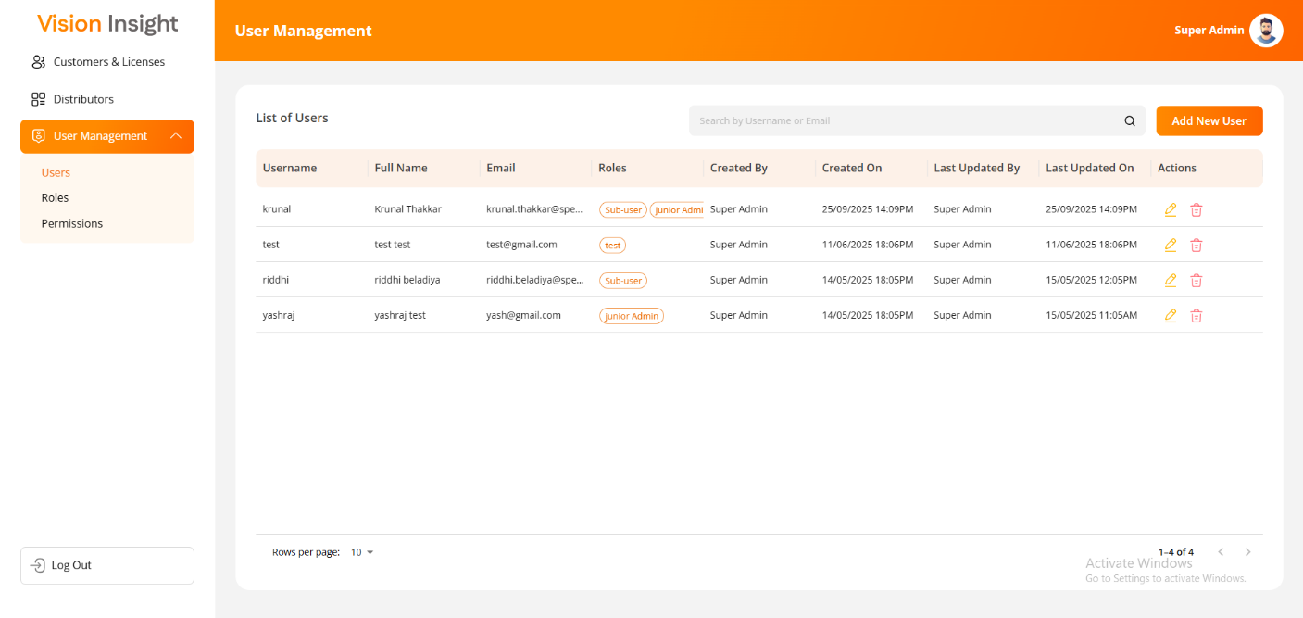

- Overview
- The User Management module enables administrators to:
    - View the list of existing users.
    - Add new users.
    - Edit or update user details.
    - Delete users (soft delete).
    - Assign one or more roles to each user.
    - Verify email addresses through OTP-based validation.

- Navigation
- To access this module:
    - Log in to the License Web Application.
    - Navigate to User Management from the main menu.
    - Select Users.

- Users List Page
- The Users List page displays all users created in the system, along with their details and available actions.
  - Available Actions
    - Search: Find a specific user by name, username, or email address.
    - Add User: Opens the form to create a new user.
    - Edit: Allows modification of user details.
    - Delete: Deletes a user after confirmation (soft delete).

  - Filter and Sort Options
    - The system provides filters like Sort By (ASC/DESC), Filter, Hide Column, and Manage Columns.
    - Filters and sorting preferences will reset when the user reloads or navigates away from the page.

  - Display Behavior
    - The page layout and functionality appear exactly as shown in the system interface (refer to provided screenshot).
    - Unauthorized menu options will remain hidden based on user permissions.

- Add New User

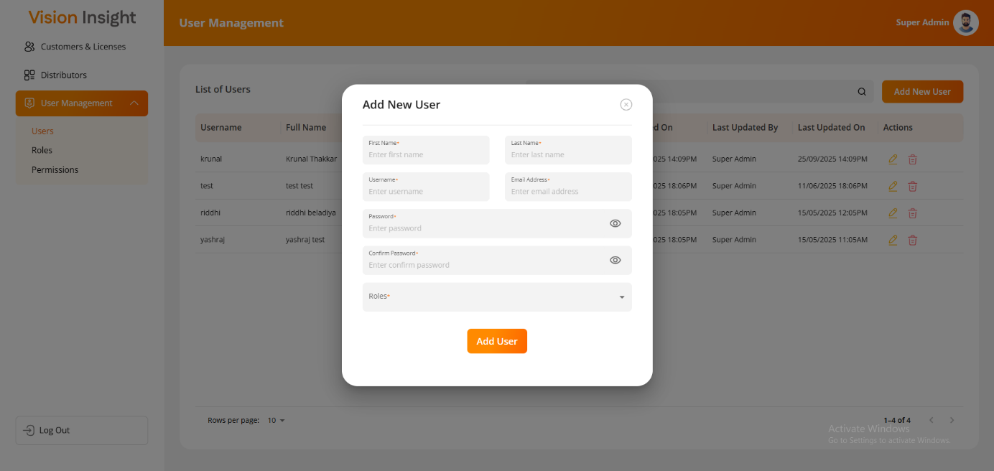

  - The Add New User form enables the authorized user to create a new sub-user by entering essential details.

  - Steps to Add a New User
    - Click Add User on the Users List page.
    - Enter the following mandatory fields:
      - First Name*
      - Last Name*
      - Username*
      - Email Address*
      - Password*
      - Confirm Password*
      - Roles*
    - Click Submit to create the new user.
    - The system will send an OTP to the entered email address for verification.
    - Enter the OTP to complete the verification process.

  - Password Criteria
    - The password must meet the following security requirements:
      - Minimum 8 characters
      - At least 1 uppercase letter
      - At least 1 lowercase letter
      - At least 1 numeric digit
      - At least 1 special character (excluding “*”)

⚠️ Note: The system will not allow duplicate usernames or email addresses. These fields must be unique for each user.

- Edit User

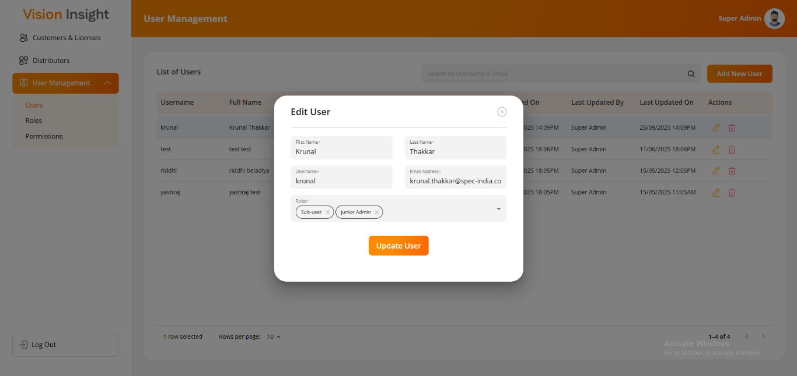

  - The Edit User form allows administrators to update existing user details, excluding password fields (since users can change or reset their own passwords).

  - Steps to Edit a User
    - Click the Edit icon corresponding to the desired user record.
    - Update the necessary details.
      - Editable Fields:
        - First Name*
        - Last Name*
        - Username*
        - Email Address*
        - Roles*
    - If the Email Address is updated, the system will trigger OTP verification.
    - Once verified, click Update to save the changes.

🔒 Note: The Password and Confirm Password fields will be hidden during editing.

- Delete User

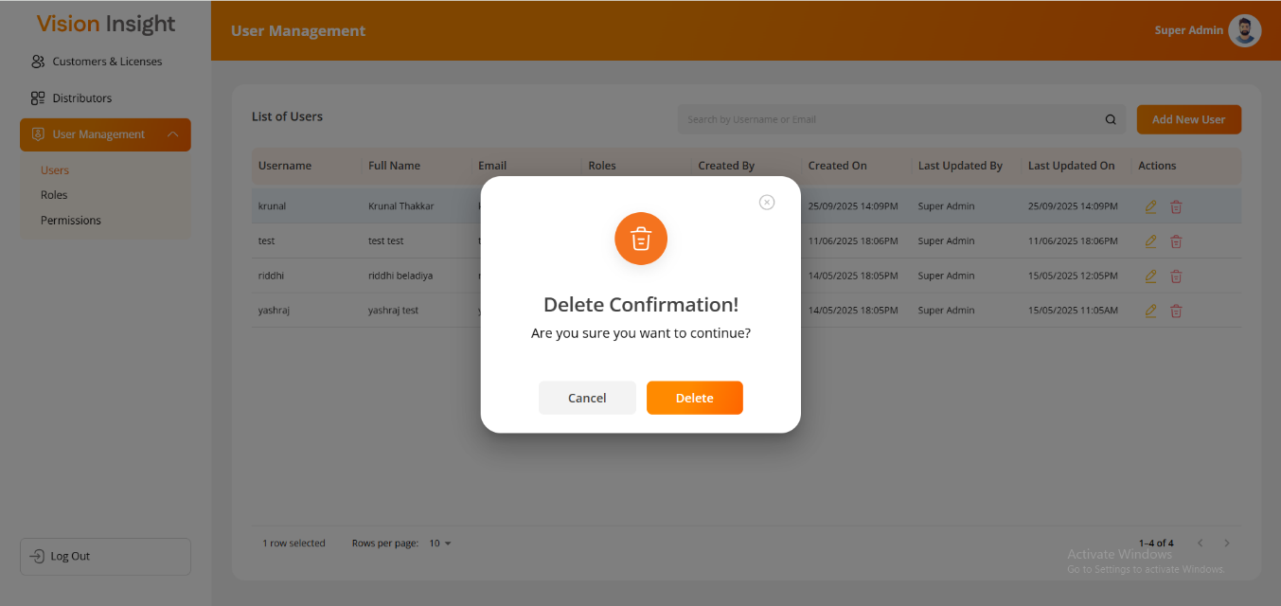

  - The system allows administrators to delete a user after confirmation.

  - Steps to Delete a User
    - Click the Delete icon next to the user’s record.
    - The system will display a confirmation message before proceeding.
    - Upon confirmation, the system will soft delete the user.
      - The user’s record remains in the database but becomes invisible in the web application.

- System Behavior and Business Rules
  - Only authorized users can create, update, or delete sub-users.
  - Duplicate email addresses or usernames are not allowed.
  - OTP verification is mandatory when updating an email address.
  - The system automatically hides any menus or options not permitted for the logged-in user based on their assigned role.
  - All users will have access to the following common options:
    - Profile
    - Change Password
    - Logout

- Field Legend
Field Name | Description | Mandatory | Notes
First Name | User’s first name | Yes | Text only
Last Name | User’s last name | Yes | Text only
Username | Unique login identifier | Yes | Must be unique
Email Address | User’s official email address | Yes | OTP verification required
Password | Login password | Yes | Hidden during edit
Confirm Password | Re-enter password for confirmation | Yes | Hidden during edit
Roles | Assign one or more roles to the user | Yes | Multiple selection allowed

- Error Handling
  - If a duplicate email or username is entered, the system will display an error message: “Username or Email already exists. Please choose a different one.”
  - If OTP verification fails, the system will prompt: “Invalid OTP. Please try again.”

Roles:

The Roles Page allows authorized users to create, view, update, and manage user roles within the License Web Application.
Roles define the level of access and permissions assigned to sub-users, ensuring that each user can perform actions according to their responsibilities.

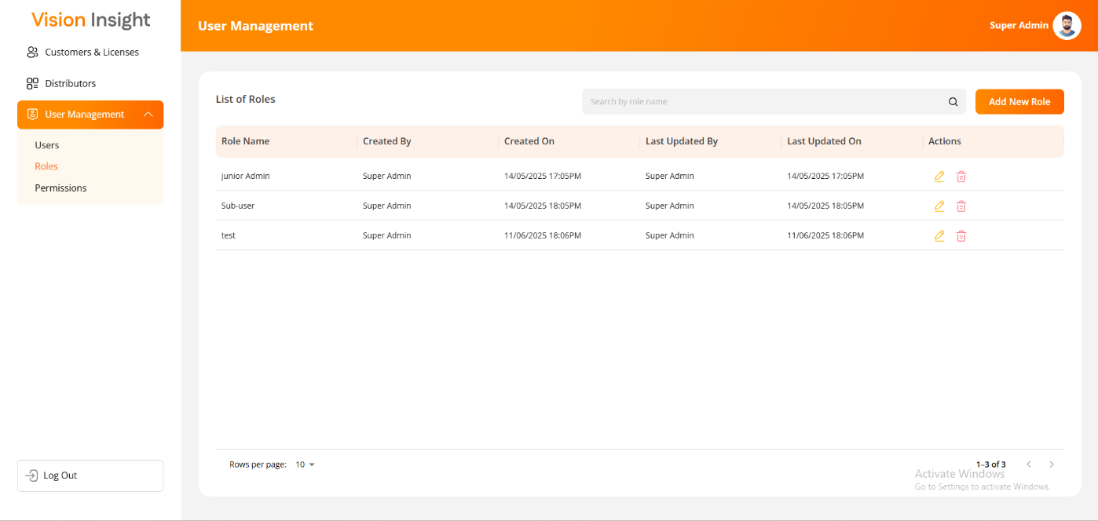

- Overview
  - The Role Management feature enables administrators to:
      - View all roles created in the system.
      - Add new roles with descriptions.
      - Edit existing roles and their details.
      - Delete roles (with system restrictions).
      - Assign roles to sub-users during user creation or modification.
- Navigation
  - To access the Roles Page:
      - Log in to the License Web Application.
      - Navigate to User Management in the main menu.
      - Select Roles.
- Roles List Page
  - The Roles List Page displays all roles currently available in the system. Each role entry includes details such as Role Name and Description, along with available actions.

  - Available Actions
      - Search: Search for roles by name or description.
      - Add Role: Create a new role.
      - Edit: Modify an existing role.
      - Delete: Remove a role after confirmation (if eligible).

  - Filter and Sort Options
      - Users can apply filters such as Sort By (ASC/DESC), Filter, Hide Column, and Manage Columns.
      - All filters and sorting preferences reset automatically when the user reloads the page or navigates away.

  - Display Behavior
      - The page layout and functionality appear exactly as shown in the system interface (refer to provided screenshot).
      - Unauthorized options are hidden automatically according to the user’s access permissions.

- Add New Role

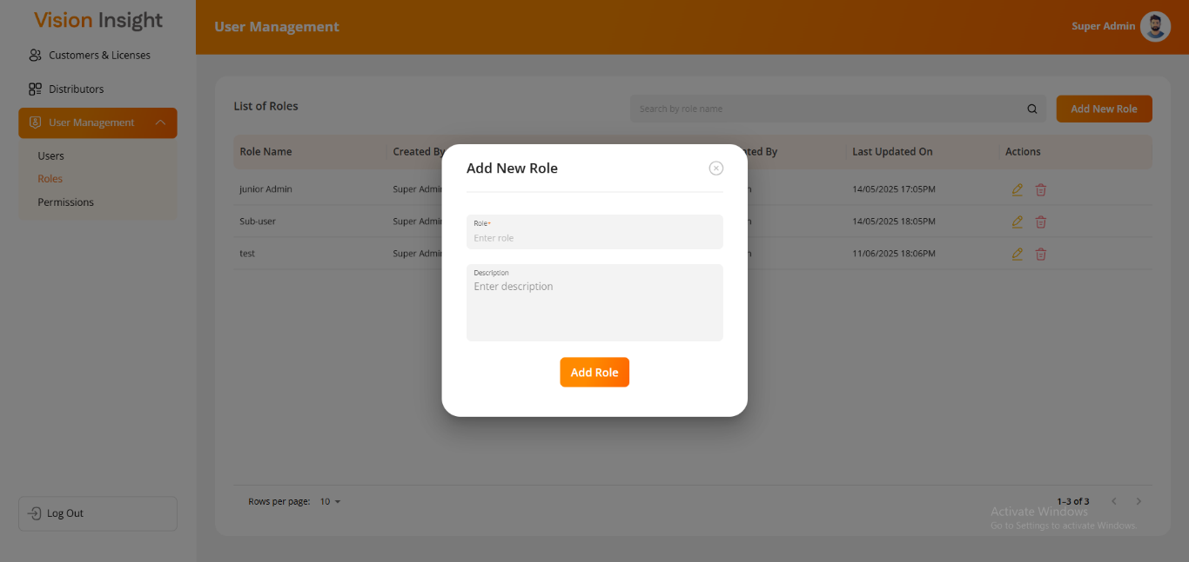

  - The Add New Role function enables the authorized user to define new user roles that can later be assigned to sub-users.

  - Steps to Add a New Role
      - Click on Add Role from the Roles List page.
      - Enter the required details in the form fields:
        - Role Name*
        - Description (optional)
      - Click Submit to save the new role.
      - The system will validate that the Role Name is unique before saving.

⚠️ Note: The system will not allow duplicate role names. Each role must have a unique identifier.

- Edit Role

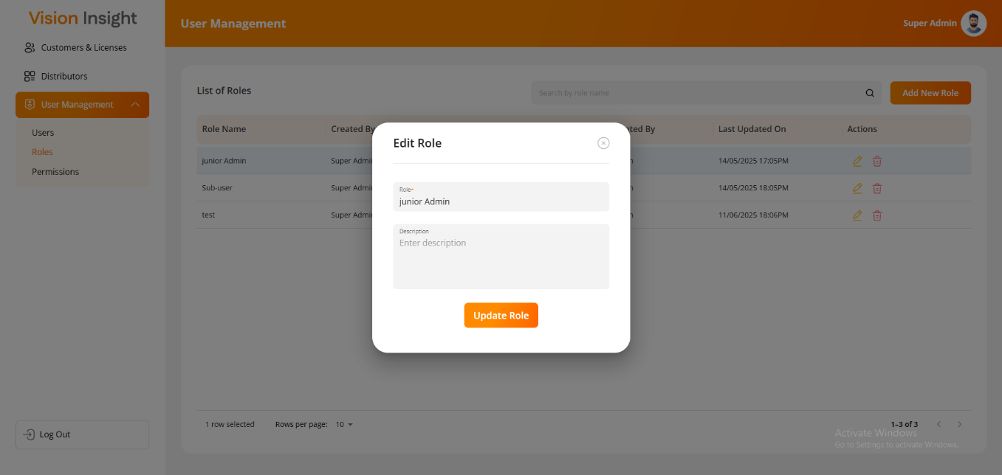

  - The Edit Role form allows the administrator to modify an existing role’s details.

  - Steps to Edit a Role
      - Click on the Edit icon corresponding to the role you wish to update.
      - Modify the required fields:
        - Role Name*
        - Description
      - Click Update to save the changes.
      - The system ensures that updated role names remain unique across the platform.

🔒 Note: The system will not allow changes that would result in a duplicate role entry.

- Delete Role
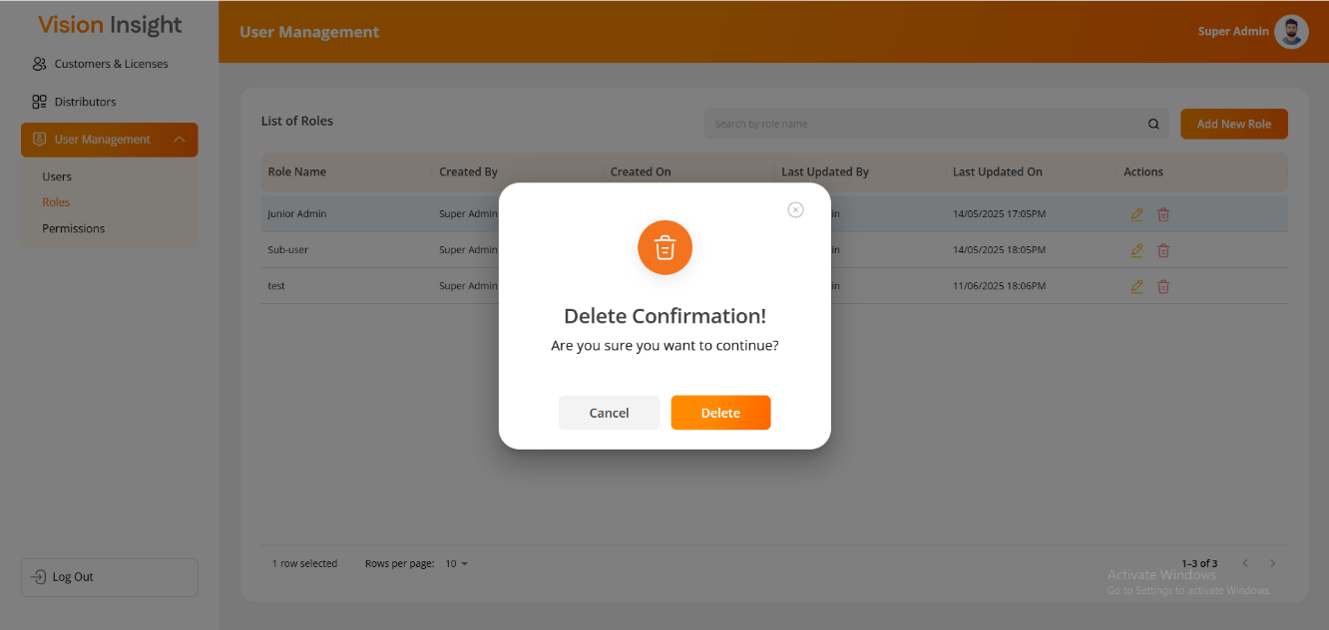

  - The system allows administrators to delete a role only if it is not currently assigned to any user.

  - Steps to Delete a Role
      - Click the Delete icon next to the role entry.
      - The system will display a confirmation prompt before deletion.
      - Upon confirmation:
        - If the role is not assigned to any user → the system performs a soft delete.
        - If the role is assigned to one or more users → the system will block deletion and display an appropriate message.
  - System Confirmation
      - “Are you sure you want to delete this role?”
  - If deletion proceeds, the record remains in the database but will no longer be visible in the web application.

- System Behavior and Business Rules
  - Only authorized users can create, update, or delete roles.
  - Deletion Restriction: Roles associated with any existing users cannot be deleted.
  - Duplicate Prevention: The system prevents duplicate role entries or redundant user-role mappings.
  - Soft Deletion: When a role is deleted, it remains in the database for record-keeping but is hidden from the user interface.
  - The Add New Role and Edit Role screens will contain the following fields:
      - Role Name*
      - Description
  - The asterisk (*) indicates a mandatory field.
  - The system provides filter and sorting capabilities, these filters reset when navigating or refreshing.

- Field Legend
Field Name | Description | Mandatory | Notes
Role Name | The name or title of the user role | Yes | Must be unique
Description | A short explanation of the role’s purpose | No | Optional text

- Error Handling
  - If a duplicate role name is entered:
      - “Role name already exists. Please choose a different one.”
  - If the role is assigned to any user:
      - “This role cannot be deleted as it is currently assigned to one or more users.”
  - If confirmation is canceled:
      - “Role deletion canceled by user.”

Permissions

The Permission page enables the authorized users to define and manage screen-level permissions for each role within the License Web Application.
This ensures that users can only access and perform actions that align with their assigned roles and responsibilities.
Through this interface, administrators can configure granular access rights such as Add, Update, Delete, and View for each screen or module in the system.
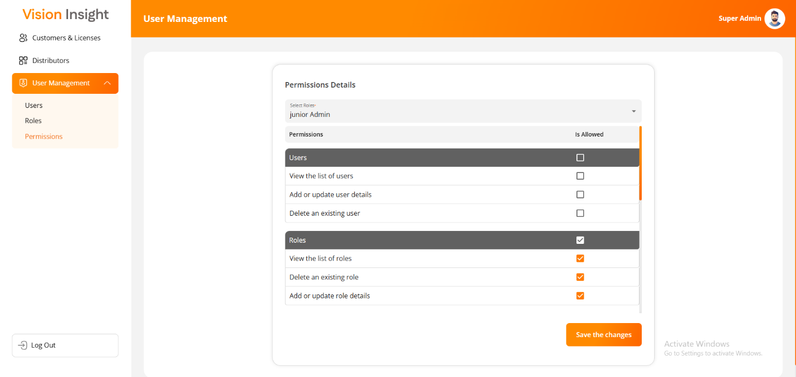

- Overview
  - The Permission module serves as the backbone of the application’s Role-Based Access Control (RBAC) system
  - It allows the authorized users to:
      - Assign or update permissions for each defined role.
      - Grant or restrict access to specific screens and functionalities.
      - Control actions such as Add, Edit, Delete, or View for each screen.
      - Ensure users can only access functionalities tied to their assigned roles.
  - When a user logs in, their access is dynamically determined based on the permissions assigned to their role(s).

- Navigation
  - To access the Permissions module:
      - Log in to the License Web Application.
      - Navigate to User Management → Permissions.
      - The Permissions configuration interface will be displayed.

- Permissions Configuration Page
  - The Role assignment page displays all system screens and their corresponding actions.
Authorized users can define which actions are allowed for each user.

- Steps to Configure Permissions
  - Go to User Management → Permissions.
  - Select the Role for which you want to manage permissions.
  - The system will display a grid or table showing all available Screens / Actions.
  - For each screen:
      - Check the box next to actions you wish to grant (Add, Update, Delete, View).
      - Uncheck the box to revoke permissions.
  - Click Save to apply changes.
  - The system will confirm that permissions were successfully updated.
  - The updated permissions will take effect after the affected users log out and log back in.
💡 Tip: Use the Select All / Deselect All feature (if available) to manage bulk permissions efficiently.

- Field Reference: Permissions Configuration Section
Field Name / Column | Description | Type | Notes
Role Name | Selects the role for which permissions are being configured | Dropdown | Mandatory field
Screen / Module | The name of the functional screen or module | Display Text | System-defined
Add | Grants permission to create new records | Checkbox | Optional per role
Update | Grants permission to modify existing records | Checkbox | Optional per role
Delete | Grants permission to remove records | Checkbox | Optional per role
View | Grants permission to view records or details | Checkbox | Optional per role

- Validation & Restrictions
  - Permissions cannot be assigned to screens or actions not applicable to that module.
  - System prevents duplicate permission assignments.
  - Permissions cannot be configured for roles that are deleted or inactive.
  - Users only see screens/actions for which their assigned roles have explicit permission.
  - The system validates all entries before saving and provides appropriate error messages.

Role Assignment:
The Role Assignment feature enables authorized users to assign one or multiple roles to a specific user within the License Web Application.
This functionality ensures that users receive access rights appropriate to their responsibilities, job roles, and hierarchy within the organization.
Once roles are assigned, the system automatically restricts or grants access to functionalities according to those role permissions.
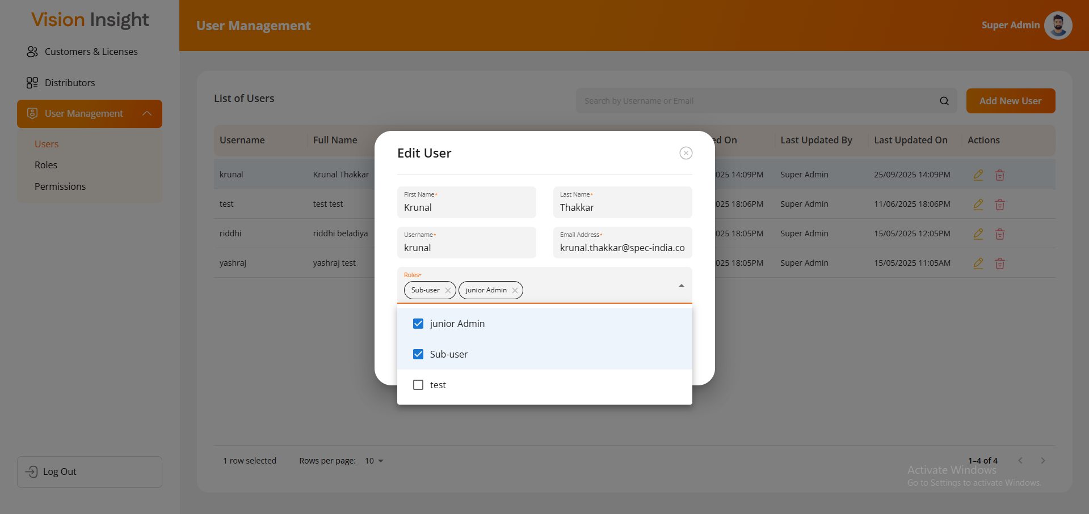

- Overview
  - After roles have been created and defined in the system (via the Roles Page), they can be assigned to users from the Users Page.
  - Each user can hold one or more roles, depending on their responsibilities. These assigned roles determine the user’s access to screens, menus, and actions within the system.
  - The Role Assignment process can occur in two ways:
      - During user creation (while adding a new user).
      - During user update (while editing an existing user).

    - Navigation
      - To access Role Assignment:
        - Log in to the License Web Application.
        - Navigate to User Management → Users.
        - From the Users list, either:
          - Click Add User to create a new user, or
          - Click Edit next to an existing user to modify their roles.
        - In the form displayed, use the Roles dropdown to assign one or more roles to the user.

    - Assigning Roles During User Creation
      - While creating a new user, the authorized user can assign one or multiple roles directly from the Add User form.
      - This ensures that the new user gains the correct permissions immediately upon account creation.
      - Steps to Assign Roles
        - Go to User Management → Users.
        - Click Add User.
        - Fill out all required user details:
          - First Name
          - Last Name
          - Username
          - Email Address
          - Password and Confirm Password
        - In the Roles* field, select one or multiple roles from the dropdown list.
        - Click Submit to create the user and save the assigned roles.
        - The system will automatically apply the selected role permissions to the new user’s account.
💡 Tip: Use the multi-select feature in the Roles dropdown to assign multiple roles to the same user.
    - Updating or Modifying Role Assignments
      - Role assignments can be modified at any time for an existing user through the Edit User screen.
      - This allows the authorized user to update a user’s access level as their responsibilities change.
      - Steps to Update Roles
        - Navigate to User Management → Users.
        - Locate the user and click Edit.
        - In the Roles dropdown, modify the assigned roles by selecting or deselecting from the available options.
        - Click Update to save the changes.
        - The system will confirm the successful update.
        - The updated role permissions will take effect after the user logs out and logs back in.
⚠️ Note: Role assignment changes are reflected only after re-login to ensure the system

- Distributors Management
The Distributors Page allows authorized users to create, view, edit, and manage distributor information within the License Web Application.
This module is designed to help administrators maintain an up-to-date record of distributors, ensuring that distributor details are properly captured and managed within the system.
Only authorized users with appropriate permissions can access this page and perform actions such as Add, Edit, and Delete distributors.

- Overview

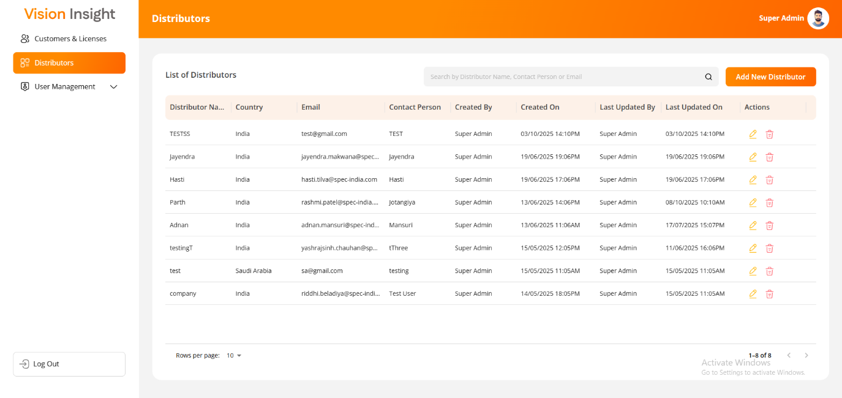

  - The Distributors Management feature enables administrators to:
      - View a list of all registered distributors.
      - Create new distributors.
      - Edit distributor information.
      - Delete distributor records (soft delete).
      - Search and filter distributors for quick access.
      - Maintain data integrity through duplicate validation and association checks.
  - This functionality ensures the accurate tracking and management of all distributors associated with the system.

- Navigation
  - To access the Distributors Page:
      - Log in to the License Web Application.
      - Navigate to Distributors from the main menu or the Master Management section (as applicable).
      - The Distributors List Page will be displayed.

- Distributors List Page
  - The Distributors List Page displays all the existing distributors created in the system, with options for searching, sorting, adding, editing, and deleting records.

  - Available Actions
      - Search: Quickly locate a distributor using keywords such as name, country, or contact person.
      - Add Distributor: Open a form to create a new distributor record.
      - Edit: Update details for an existing distributor.
      - Delete: Remove a distributor record (soft delete, after confirmation).

  - Filter and Sort Options
      - The system provides advanced filtering options like Sort by (ASC/DESC), Hide Columns, and Manage Columns.
      - Filters and sorting preferences automatically reset when the user refreshes or navigates to another page.

  - Display Behavior
      - The page layout and functionality appear exactly as shown in the system interface (refer to provided screenshot).
      - The available actions (Add, Edit, Delete) are displayed based on the logged-in user’s permissions.

- Add New Distributor

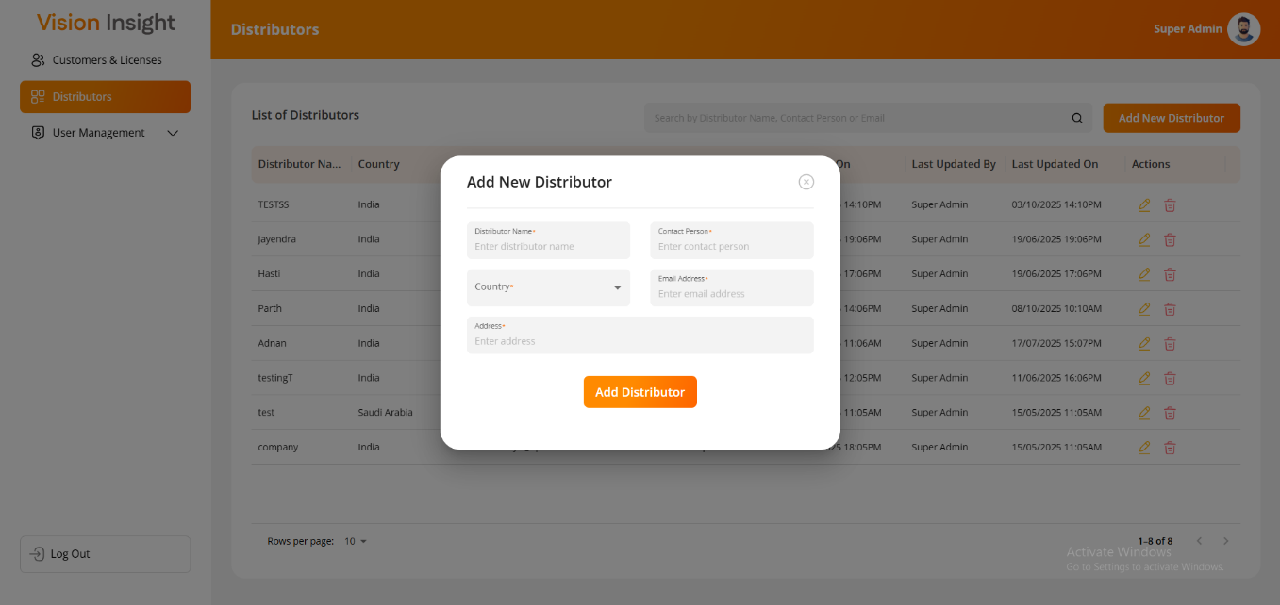

  - Authorized users can create a new distributor by entering essential details in the Add New Distributor form.

  - Steps to Add a Distributor
      - Navigate to the Distributors Page.
      - Click the Add Distributor button.
      - Fill in the following required fields:
        - Distributor Name*
        - Contact Person*
        - Country*
        - Email Address*
        - Address*
      - Click Submit or Save to add the distributor.
      - The system validates:
        - That all mandatory fields are filled.
        - That the Distributor Name does not already exist in the system.
      - Upon successful submission, the new distributor will appear in the list view.

⚠️ Note: Duplicate distributor names are not allowed. The system will display a validation message if a duplicate entry is detected.

- Edit Distributor

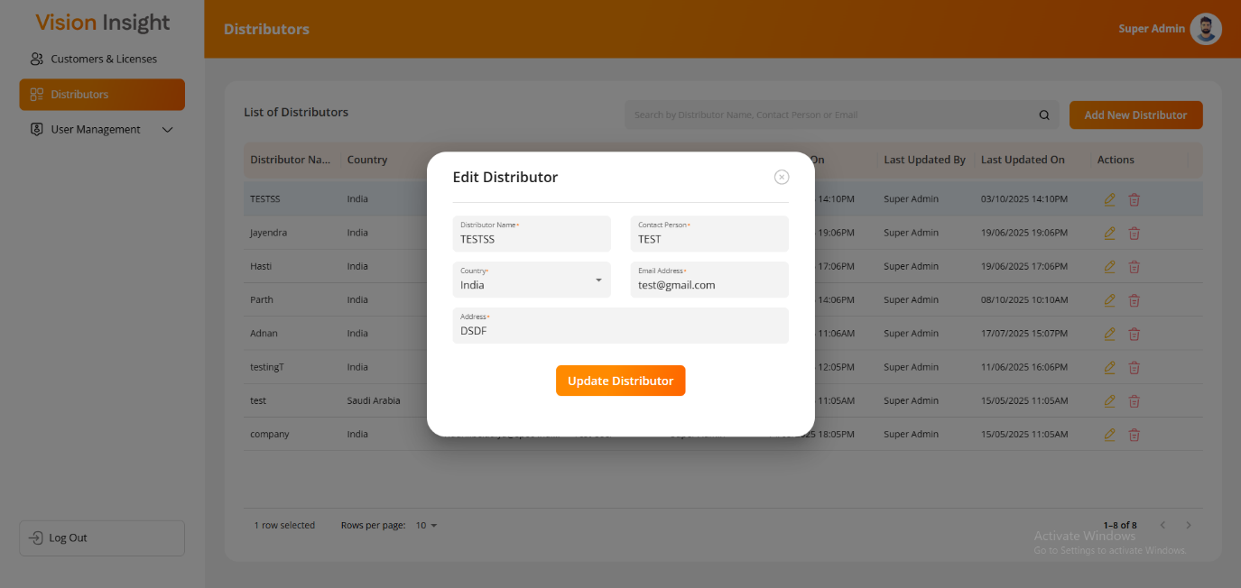

  - The Edit Distributor functionality allows users to modify details of an existing distributor when necessary.

  - Steps to Edit a Distributor
      - From the Distributors List Page, locate the distributor to be updated.
      - Click the Edit icon next to the distributor record.
      - The system displays the Edit Distributor form, pre-filled with existing data.
      - Modify the required fields such as Contact Person, Email Address, or Address.
      - Click Update to save the changes.
      - The system validates the changes before saving and confirms the update with a success message.

💡 Tip: Editing a distributor does not require re-entering all fields; only the modified information needs to be updated.
- Delete Distributor

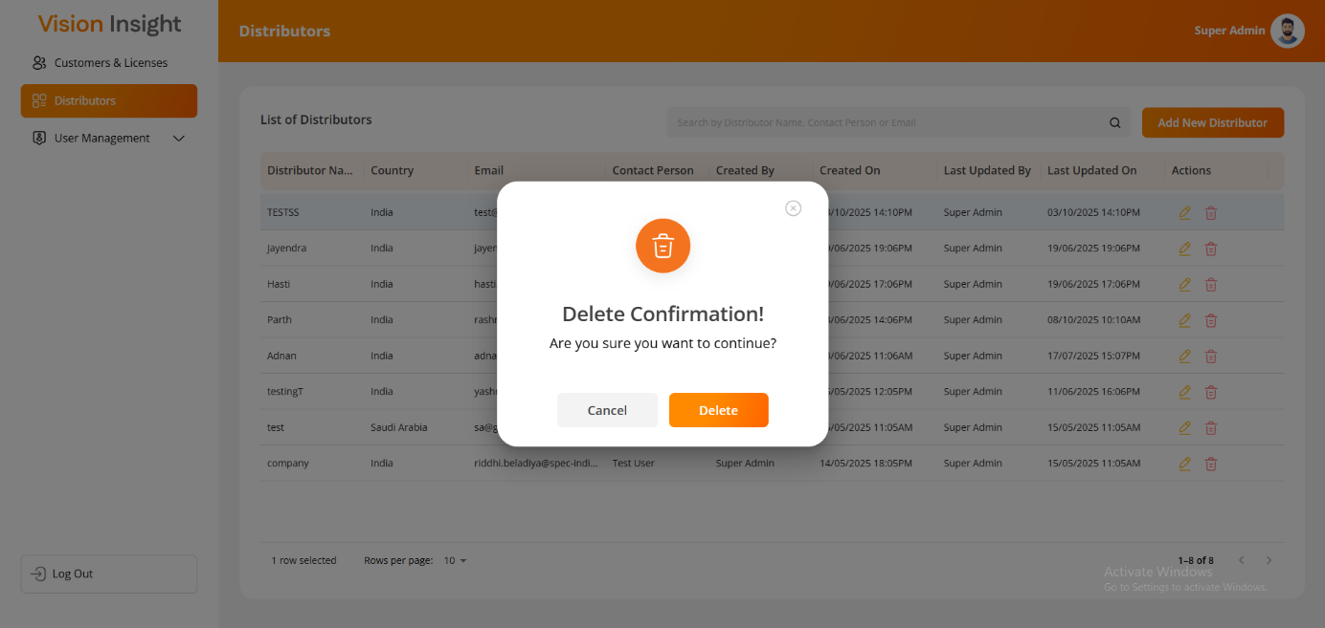

  - The system allows authorized users to delete a distributor after confirmation. Deletion is soft, meaning the record remains in the database but is no longer visible in the web interface.

  - Steps to Delete a Distributor
      - From the Distributors List Page, identify the distributor you wish to delete.
      - Click the Delete icon next to the record.
      - The system will display a confirmation prompt asking for user confirmation.
      - If the distributor is associated with an active customer, the system will restrict deletion.
      - If not associated, confirm the action to perform a soft delete.

  - System Confirmation Message
      - “Are you sure you want to delete this distributor?”

🔒 Note: Distributors associated with active customers cannot be deleted until the association is removed.

- Field Reference: Distributor Management
Field Name | Description | Type | Mandatory | Notes
Distributor Name | Unique name of the distributor | Text Box | Yes | Must be unique
Contact Person | Main point of contact for the distributor | Text Box | Yes | —
Country | Country where the distributor is located | Dropdown | Yes | Predefined country list
Email Address | Distributor’s contact email | Text Box | Yes | Must follow valid email format
Address | Physical address of the distributor | Text Area | Yes | —

- Validation Rules
  - The system validates that all mandatory fields are filled before submission.
  - Duplicate distributor names are not allowed.
  - Email Address must follow a valid format (e.g., name@domain.com).
  - Country must be selected from the predefined list.
  - Delete action is restricted if the distributor is linked with any active customer.

- Customers & Licenses Management
The Customers & Licenses Page allows authorized users to create, view, update, and manage customer records along with their associated license details within the License Web Application.
This module serves as the core component for maintaining customer information, managing their license types (Trial or Permanent), and performing all related actions such as generating, upgrading, and resending license files.
The page is accessible only to authorized users, with visible actions and functionalities determined by their assigned permissions.

- Overview
  - The Customers & Licenses section provides administrators with the ability to:
      - Create, update, and manage customer details.
      - View and manage license details for each customer.
      - Generate new licenses (Permanent or Trial).
      - Upgrade or Resend existing license files.
      - Enforce business rules around license creation limits, validity, and encryption.
      - Maintain complete visibility into customer-license relationships.

  - This is also the default landing page after successful login for authorized users.

- Navigation
  - To access this section:
      - Log in to the License Web Application.
      - Navigate to Customers & Licenses from the main menu.
      - The Customers List Page will appear displaying all registered customers.

Customers:

The Customers List Page displays all created customers in a tabular format, including search and action options.
Authorized users can perform Add, Edit, Delete, and View License Details operations based on their permissions.

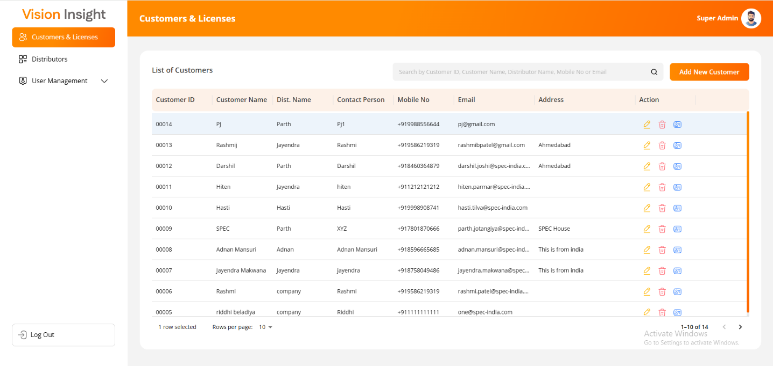

- The Customers List Page displays all created customers in a tabular format, including search and action options.
- Authorized users can perform Add, Edit, Delete, and View License Details operations based on their permissions.

- Available Actions
  - Search: Locate a customer using name, email, or distributor.
  - Add Customer: Open a form to create a new customer record.
  - Edit Customer: Modify details for an existing customer.
  - Delete Customer: Soft delete a customer after confirmation.
  - View License Details: Access all licenses associated with a specific customer.

- Filter Options
  - Filters and sorting can be applied to specific columns such as Customer Name, Country, Distributor, etc.
  - All filters reset upon page reload or navigation.

- Add New Customer
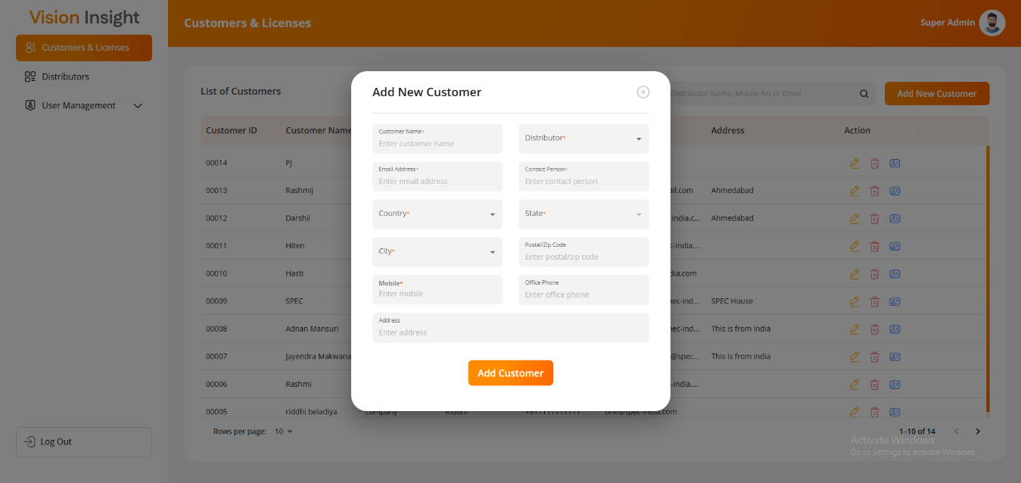

  - Authorized users can add new customers by filling in required details in the Add New Customer form.

  - Steps to Add a Customer
      - Click Add Customer from the Customers List Page.
      - Fill in the following required details:
        - Customer Name*
        - Distributor*
        - Email Address*
        - Contact Person*
        - Country*
        - State*
        - City*
        - Postal / Zip Code
        - Mobile*
        - Office Phone
        - Address
      - Click Submit to save the record.
      - The system validates the form and ensures that duplicate customer entries are not allowed.
      - Upon successful creation, the customer appears in the customer list.

⚠️ Note: A customer cannot be created with a duplicate name or email address.

- Edit Customer
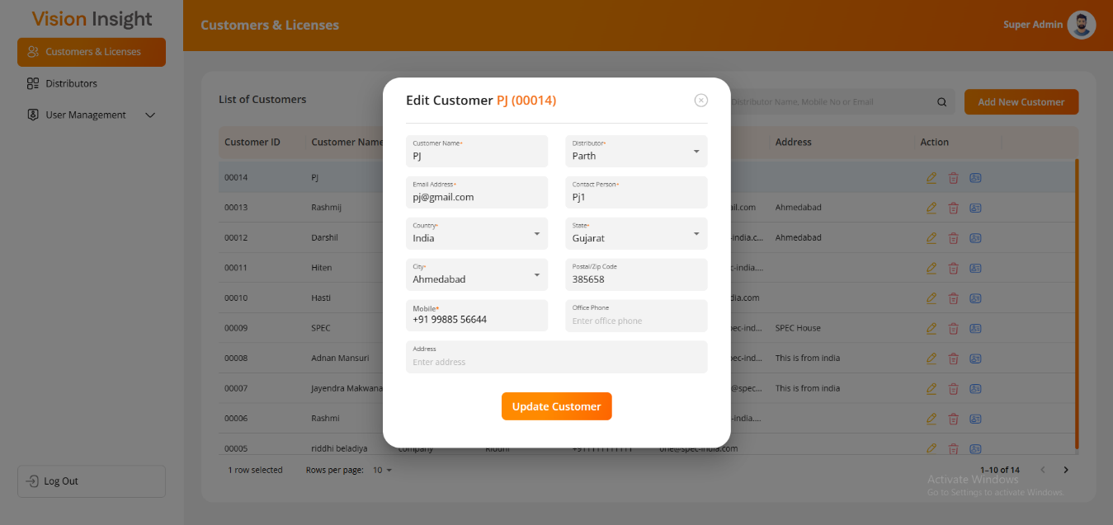

  - The Edit Customer Screen allows authorized users to update the details of an existing customer.

  - Steps to Edit a customer
      - Locate the desired customer record on the Customers List Page.
      - Click the Edit icon.
      - Update necessary information in the Edit Customer form.
      - Click Update to save changes.
      - The system validates updated fields before saving.

- Delete Customer

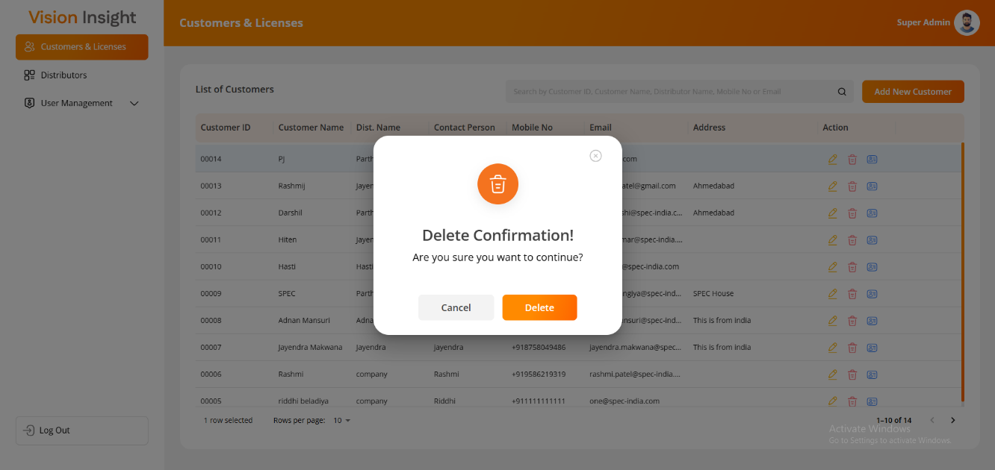

  - Customers can be deleted from the system after confirmation.
  - The deletion is soft delete, meaning the record remains in the database but is hidden from the web interface.

  - Steps to Delete a customer
      - On the Customers List Page, click the Delete icon next to the desired record.
      - A confirmation prompt appears to ensure the action is intentional.
      - If confirmed:
        - If the customer has no active licenses, the system soft deletes the record.
        - If the customer has one or more active licenses, deletion is blocked.
    - Confirmation Message
      - “Are you sure you want to delete this customer?”
🔒 Note: A customer cannot be deleted if they have one or more active licenses.

Licenses:

The License Management section allows users to create and manage Trial and Permanent Licenses for each customer.
This section is accessed from the View License Details option in the Customers List.

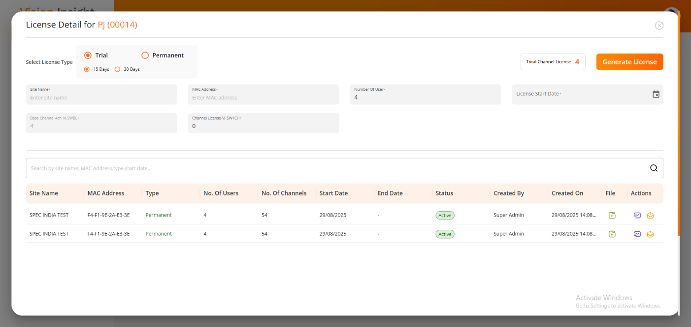

- View License Details
  - When a customer is selected, License Details Modal Popup displays all existing licenses for that customer along with their current status.
  - If no licenses exist, users can create a new license from the same screen.

- License Details Columns
Column Name | Description
Site Name | The installation or deployment site
MAC Address | Unique hardware identifier tied to the license
Type | Trial or Permanent
No. of Users | Number of users allowed
No. of Channels | Channels included in the license
Start Date | License activation date
End Date | License expiry date (blank for Permanent)
Status | Active / Expired / Future
Created By | Username of the creator
Created On | Date of license creation
File | Option to download the license file
Actions | Resend and Upgrade options

- Filtering Options
  - Licenses can be filtered by:
      - Site Name
      - MAC Address
      - Type
      - Start Date

- Add New License
  - Authorized users can generate new licenses (Trial or Permanent) for any customer.
Each license is linked to a specific MAC Address and Site Name to ensure security and authenticity.
  - Steps to Generate a License
      - Click Add License within the License Details section.
      - Choose the License Type:
        - Trial License
        - Permanent License
      - Fill in the fields based on the selected license type.

- Permanent License Fields
  - Site Name*
  - MAC Address*
  - Number of Users*
  - License Start Date*
  - Base Channel 4ch-VI-SWBL*
  - Channel License-VI-SW1CH*

- Trial License Fields
  - Duration* (15 days or 30 days)
  - Site Name*
  - MAC Address*
  - Number of Users
  - Number of Channels*
  - License Start Date*
⚠️ Rules for Trial Licenses:
- Maximum duration: 30 days
- Maximum two trial licenses per customer (each up to 30 days)

- License Generation and Actions
  - Generate License
      - Once all mandatory fields are filled, click the Generate License button.
      - A confirmation message will appear displaying license details.
      - After clicking Proceed, the system will:
        - Generate the license file in encrypted format.
        - Send the license file to the associated distributor’s email as an attachment.

- Resend License
  - Clicking Resend in the Actions column will send the existing license file again to the distributor.
  - The system displays a message confirming the resend operation.

- Upgrade License
  - Users can click Upgrade to open the existing license details in editable form.
  - Modify necessary fields and click Generate License again.
  - The system will create a new entry for the upgraded license.
🔐 Note: Each license file is machine-specific and encrypted to prevent unauthorized use.

- Field Reference: Customer Management

Field Name | Description | Type | Mandatory | Notes
Customer Name | Customer’s name | Text | Yes | Must be unique
Distributor | Linked distributor | Dropdown | Yes | Predefined list
Email Address | Customer’s email | Text | Yes | Unique, valid format
Contact Person | Main contact for the customer | Text | Yes | —
Country / State / City | Location details | Dropdown/Text | Yes | Country and State mandatory
Postal / Zip Code | Customer’s postal code | Text | No | —
Mobile | Mobile number | Text | Yes | Must be numeric
Office Phone | Office contact number | Text | No | —
Address | Physical address | Text Area | No | —

- Profile & Password Management

- This section explains how admin users can view their profile details, update their profile picture, and change their account password.

Profile:
The Profile Page allows all users to view their registered account details within the License Web Application.
This page is accessible to every logged-in user and provides a summary of their personal and account-related information, such as profile image, name, username, email address, and assigned roles.
The page ensures transparency for users by allowing them to review their stored details and update their profile picture if desired.
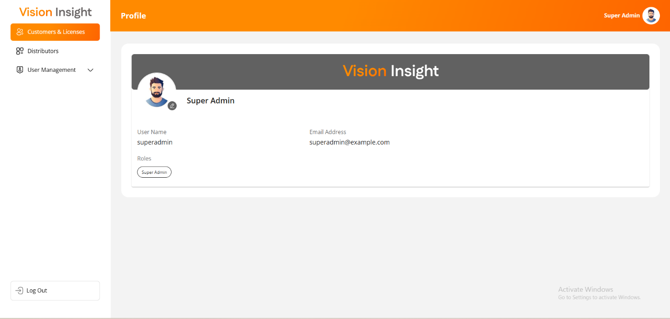

- Overview
  - The Profile Page displays information fetched directly from the user’s registered record in the system database.
  - It ensures that each user can view their correct and current information in a secure and isolated environment (no access to other users’ profiles).

- Navigation
  - To access the Profile Page:
      - Log in to the License Web Application.
      - Click on the Profile link or the Profile Image located in the top-right corner of the application header.
      - The Profile Page will open, displaying details specific to the currently logged-in user.

- Profile Page Layout
  - The Profile Page displays user information in a read-only format, with the exception of the profile image.
  - All fields are automatically populated from the system database and cannot be manually edited by the user (except for the profile picture).

  - Displayed Information
      - The page includes the following details for the logged-in user:
        - Profile Image
        - Full Name (First Name & Last Name)
        - Username
        - Email Address
        - Roles (assigned from the Users module)

- Update Profile Image
  - Users can update their Profile Image directly from the Profile Page.
  - The updated image will appear across all system screens and modules after the user re-logs into the application.

  - Steps to Update Profile Image
      - Navigate to the Profile Page.
      - Click on the current Profile Image displayed on the screen.
      - A file selection dialog box will appear.
      - Choose the new image file from your local system (supported formats: JPG, PNG, JPEG).
      - Confirm the upload.
      - The system will display a success message upon successful update.
      - Log out and log back in to view the updated profile image across the system.

💡 Tip: Ensure the profile image follows the organization’s image size and format guidelines to prevent display issues.

Change Password:
The Change Password Page allows all users to securely reset their existing password within the License Web Application.
This ensures user account protection and helps maintain system security by allowing users to update their credentials regularly.
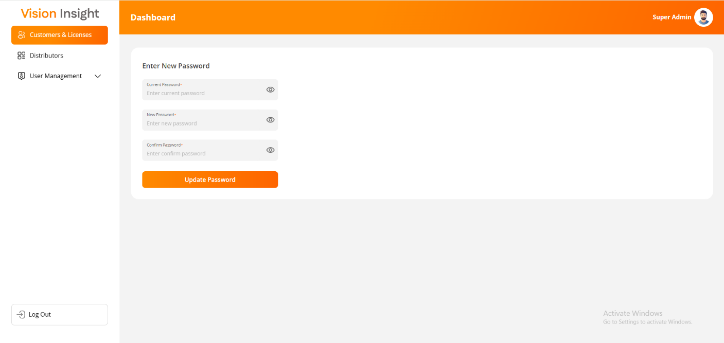

- Overview
  - The Change Password Page provides a simple, secure interface for users to update their login credentials.
  - Users are required to enter their current password (for verification) and the new password twice (for confirmation).
  - Once successfully updated, the system automatically logs the user out to ensure authentication under the new credentials.

- Navigation
  - To access the Change Password Page:
      - Log in to the License Web Application.
      - Click on the Change Password link located in the top-right corner of the application header.
      - The Change Password screen will appear.

- Change Password Form
  - The form includes three input fields that ensure secure verification and validation before updating the password.
  - Fields
      - Old Password* – Enter the current password.
      - New Password* – Enter the desired new password following the required security policy.
      - Confirm Password* – Re-enter the new password to confirm correctness.
  - All three fields are mandatory.

- Password Update Process
  - Steps to Change Password
      - Navigate to Change Password from the top menu.
      - Enter your Old Password in the first field.
      - Enter your New Password in the second field.
      - Re-enter the New Password in the Confirm Password field.
      - Click the Submit button.
      - The system will validate the credentials as follows:
        - If the Old Password is correct:
          - The system updates the password in the database.
          - The user is automatically logged out of the application.
          - The user must log in again using the new password.
          - The system sends a confirmation email notifying the user of the password change.
        - If the Old Password is incorrect:
          - The system will display an error message indicating invalid credentials.
          - No password changes will be applied.
⚠️ Note: For security purposes, passwords are stored in encrypted format and are never displayed or retrievable by any user.

- Validation Rules
  - All three fields are required before submission.
  - The New Password and Confirm Password fields must match exactly.
  - The Old Password must match the user’s current credentials.
  - If the password policy is enforced, the New Password must comply with it (for example):
      - Minimum 8 characters
      - At least one uppercase and one lowercase letter
      - At least one number and one special character
  - The system prevents using the same password as the current one.
  - The system validates password strength to ensure account security.
- Troubleshooting Tips

- This section provides a list of common issues that admin users might face and their possible solutions. It is designed to help users resolve problems quickly without IT intervention.

Issue | Solution
Login failed | Verify credentials; check account status; reset password.
OTP not received | Resend OTP; check spam/junk folder.
Screen not loading | Clear browser cache; retry supported browser.
Cannot delete distributor/customer | Ensure no active customers/licenses are linked.
License email not received | Verify distributor email; retry resend.

- Support Contact
- For any queries, issues, or assistance, please reach out to:
Name | Jayendra Makwana
Email | jayendra.makwana@spec-india.com
Support Hours | Mon-Fri, 9:00 AM – 6:00 PM IST

---- end of document ----

